GENERATION OF HIGHER NUMBER OF VOLTAGE LEVELS BY STACKING INVERTERS OF LOWER MULTILEVEL STRUCTURES WITH LOW VOLTAGE DEVICES FOR DRIVES
ABSTRACT
This paper proposes a new method of generating higher number of levels in the voltage waveform by stacking multilevel converters with lower voltage space vector structures. An important feature of this stacked structure is the use of low voltage devices while attaining higher number of levels. This will find extensive applications in electric vehicles since direct battery drive is possible. The voltages of all the capacitors in the structure can be controlled within a switching cycle using the switching state redundancies (pole voltage redundancies). This helps in reducing the capacitor size. Also, the capacitor voltages can be balanced irrespective of modulation index and load power factor. To verify the concept experimentally, a nine-level inverter is developed by stacking two five-level inverters and an induction motor is run using V/f control scheme. Both steady state and transient results are presented.

BLOCK DIAGRAM FOR PROPOSED SYSTEM
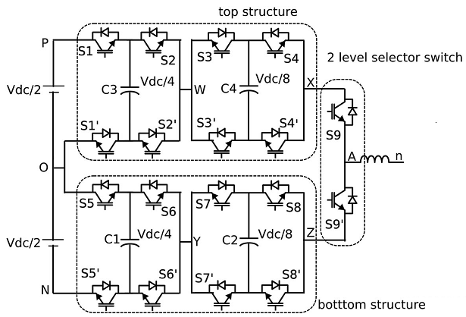
Fig. 1. Power circuit for the proposed stacked nine-level inverter and its modulating signal for phase “a.” Proposed 9 level inverter by stacking two 5 level inverters,
DESIGNG SOFTWARE AND TOOLS:
MAT LAB /SIMULATION Software and simu power systems tools are used. Mainly control system tools, power electronics and electrical elements tools are used.

